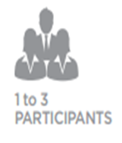
Marketing Communications:
DECA Video Challenge
www.deca.org – high school – video challenges
Procedure:
Participants should have a discussion with the yearbook staff at the school.
*Ask if DECA can assist the yearbook team by creating and implementing marketing strategies to help sell more yearbooks.
• The participants will plan and execute marketing campaigns for their schools’ yearbooks with the goal of increasing the school’s buy-rate, both in terms of copies sold and the ratio of yearbooks sold to students enrolled.
• The participants will consider the research/analysis questions prepared by Herff Jones before planning and executing the marketing campaign.
• The participants will demonstrate understanding of the importance of knowing the market, creativity in promotion and follow-through based on performance analysis.
• Cooperation with the school’s yearbook staff will provide the team with buying history, pricing information and deadlines. In some cases, the yearbook staff will have been using certain selling procedures year after year; these may be continued as this competition is centered specifically around improving the buy-rate. The DECA planned campaigns could supplement book sales at registration or a flier in the back-to-school packet.
• The participants will then present their findings to Herff Jones in a video that is a maximum of 10 minutes in length posted on YouTube. (See Presentation Guidelines.)
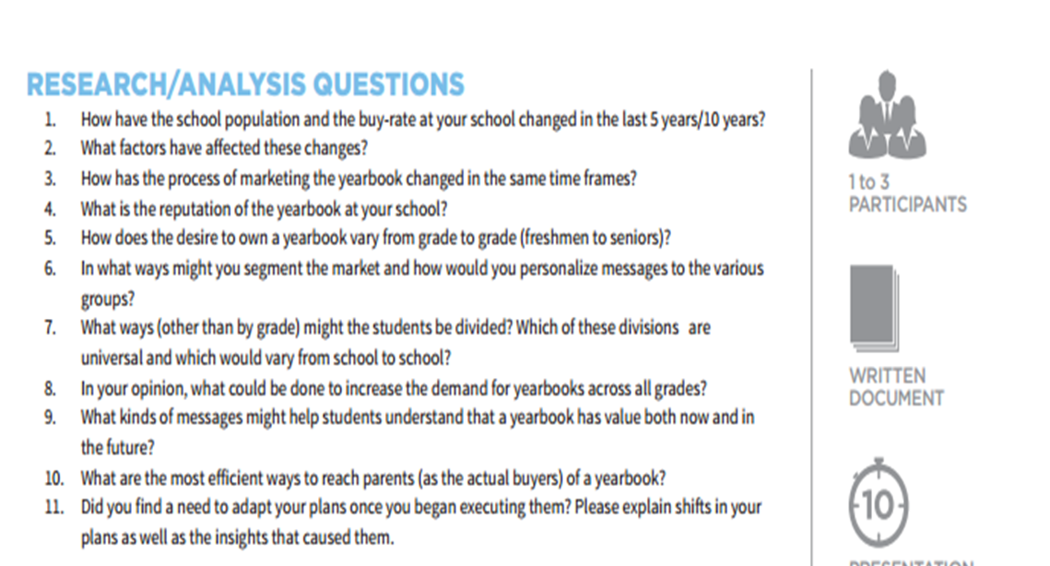
Ten Minute Video DUE Friday, December 2nd. This will be a Project grade. You will get multiple participation grades as well. If you are a DECA member, you can upload your video to YouTube and compete with your video if you make it as a finalist. Remember, ICDC is in California this year!

See Rubric on www.northsidemarketing.weebly.com - Blogs – Marketing Communications 11/3

